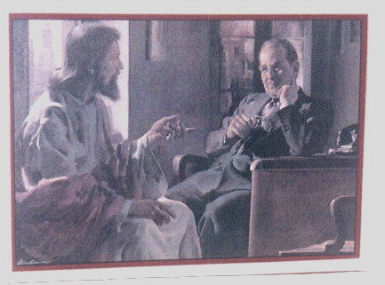
JESUS

“My Father’s Business”

“A New Command I give to you, Love
One Another, as I have Loved You, so
you must love one another. By this all
will know that you are my disciples ,
if you Love One Another.”
John 13:34-35 NIV

Jesus “Divine Counselor”
_______________________________________________________________________

“Good News”

Jesus Promises the Holy Spirit

“If you love me, you will obey what I command. And I will ask the Father, and he
will give you another Counselor to be with you forever- the Spirit of Truth. The
world cannot accept him, because it neither sees him nor knows him. But you know
him, for he lives with you and will live in you. [15-18]
Jesus replied, “If anyone loves me, he will obey my teaching. My father will love
him, and we will come to him and make our home with him. He who does not love
me will not obey my teaching. These words you hear are not my own; they belong
to the Father who sent me. All this I have spoken while still with you. But the
Counselor, the Holy Spirit, whom the Father will send in my name, will teach you all
things and will remind you of everything I have said to you. Peace I leave with you;
my peace I give you. ...But the world must learn that I love the Father and that I do
exactly what my Father has commanded me. John 14:15-31”

God’s Word Says It Best!
Study, Research, and Read the Bible in 11 Translations, and 91 languages at www.bible.com

www.giftsofmercy.org
___________________________________________________________________________________

What will Jesus do in My Marketplace? It is in accepting Jesus that we are freed!

“Whoever calls on the name of the Lord will be saved.” Acts 2:21

Books to read that encourage, motivate, and promote God’s love, the journey, the process, and a new life.

The Calvary Road, by Roy Hession Hinds Feet on High Places, by Hannah Hurnard “A Classic Series”

Love
“There is no difficulty that enough love cannot conquer; no disease that enough love will not heal; no door that enough love will not open; no gulf that enough love will not bridge; no wall that enough will not throw down; no sin that enough love will not redeem.
It makes no difference how deeply seated may be the trouble, how hopeless the outlook, how muddled the tangle, how great the mistake; a sufficient realization of love will dissolve it all. If only you could love enough you would be the happiest and most powerful being in the world.” Emmet Fox” [I Cor. 13 Love-paraphrased]

Encourage someone today!!! Send a free e-card @ www.dayspring.com Help the Needy www.giftsofmercy.org

Live each day as though it were your last, but plan as though you were living a thousand years.

Need a higher perspective? Praise and worship Jesus, “God inhabits Himself in the praises of His people”
Play Worship music 24/7 www.allworship.com www.klove.com

Grace defies the logic of legalism. “Who made us ministers of the New Covenant., not of the letter but of the spirit; for the
letter of the law kills but the spirit gives life. 2 Cor. 3:6” Ps. 35 God delivers the poor , the needy, and the righteous.

We are His hands, feet, eyes, heart, pulse, feelings, and Body until He returns. How can we love each other as He has Loved us,
and fulfill God’s Command to “Love One Another” in the world?

Guidelines for sharing and response: Share in the spirit and attitude “as one beggar sharing bread with another. We are All Equal in
Christ’s Love, and the “Cross of Jesus” is a level playing field. We want to learn and grow in the study of God’s Word, see His
Kingdom prosper, and become God’s beloved and blessed people on the earth.

